
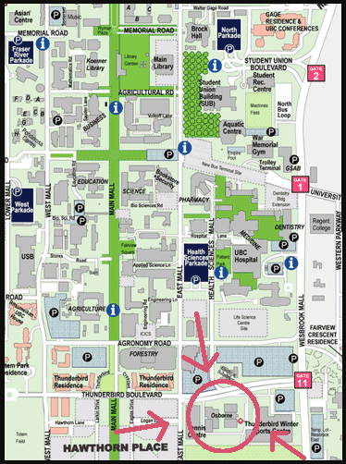
Map of where Osbourne Gym is located.

Map of where Osbourne Gym is located.

